

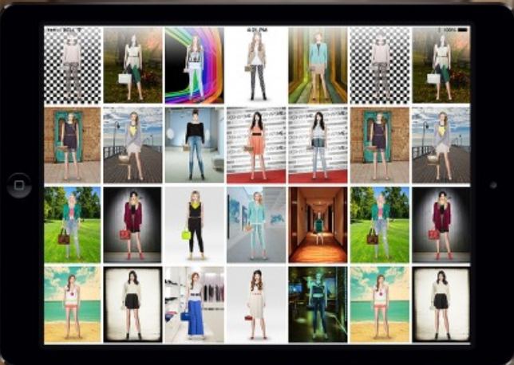

Commercial Programming 1

Integrated Project 2017

**Shopify Online Clothing App**

**Group Members: DIVAS Analysts**

|  |  |  |  |
| --- | --- | --- | --- |
| Name | Surname | Student  Numbers | Role |
| Wandisa | Nyikana | 203168283 | Programmer  (Leader) |
| Duduzile | Matiwane | 214007782 | Tester |
| Ludmila | Costa | 214010902 | Programmer |
| Tanya | Williams | 214119653 | Business  Analyst |

**Shopify Online Clothing App**

**Descriptive title:** This document describes the development of system that will build a Visual Basic program-as-a-service of an online app developed in CPUT by Commercial Programming I, group students.

**Document History and version control**

|  |  |  |  |  |
| --- | --- | --- | --- | --- |
| Revision | Name | Due Date | Requirements | Comments |
| 0.1 | Problem definition | 22nd August 2017 | Initial Draft | Initial draft submit to lecturer |
| 0.2 | Solution Scope | 22nd August  2017 | Initial Draft | Initial draft submit to lecturer, waiting for approval |
| 0.3 | Entity Relationship Diagram | 22nd August  2017 | Initial Draft | Initial draft submit to lecturer |
| 0.4 | User Interfaces Sample | 22nd August  2017 | Initial Draft | Initial Draft submit to lecturer |
| 0.5 | Database | 13th September 2017 | Initial Draft | Initial Draft submit to lecturer |
| 0.5 | Business Rules | 13th September 2017 | Initial Draft | Initial Draft submit to lecturer |

**Plagiarism Declaration**

We **Divas Analysts** declare that all information in this document has been obtained and presented in accordance with academic rules and ethical conduct. We also acknowledge that as required by these rules and conduct that was not involved any sort of copying someone’s work.

We have not allowed or will in the future allow, anyone to copy our work with the intention of passing it off as their own work.

Date: 13/09/2017

Signature: DIVAS Analysts.co

**Contents**

**INTRODUCTION** 1

**Overview** 1

**Project Objective** 1

**Problem Statement** 2

**Proposed Solution** 2

**Context Diagram of Shopify Online Clothing App** 3

**User Interfaces** 4

**Business Rules** 9

# **INTRODUCTION**

## **Overview**

The project is aimed at producing an online app that will provide operations as if it is a physical shopping. Commercial Programming 1 which 4 students are required to create an app that will run on Visual Basic.Net and have five minimum database tables that are linked to many-to-one relationships.

When designing the project the students are expected to implement the knowledge they have gained in the Information Technology Course and Commercial Programming I, subject by:

* Applying the principles of analysis and programming.
* Design development and implementation to a single project in Visual Basic.Net
* Using recognized design techniques to solve problems.
* Complete projects within a set of time.

## **Project Objective**

The objective of the project is to analyze, design and develop the online clothing app. Once the app is implemented, the students will provide an open source template, which can be reused by developers to build their own web-shops. Additionally the source code will serve as a live documentation about how to use the platform.

# 

# **Problem Statement**

Opening and sustaining a small business in our days is extremely difficult because of competition from well established businesses. Most of the businesses fail not because of the quality of the product or price but because of lack of advertisement and because the business is at a small scale therefore it ends up not reaching large scale of customers (It does not become popular).

# **Proposed Solution**

Internet has made shopping very easy for most of the people especially those who do not like shopping centers. Online shopping gives customers an easy and convenient way to shop from the comfort of their homes on a website that sells all of their favorite clothes. It also provides better information about the product and a worldwide market access of the product making it popular. The program will be built of features such as Home Page, About Us Page, Registration Page, Login Page, Shopping Cart and Adding to Basket. These give a full package of options that enable the customers to browse through the app and perform the basic shopping activities in a clear and simple way.

# **Context Diagram of Shopify Online Clothing App**

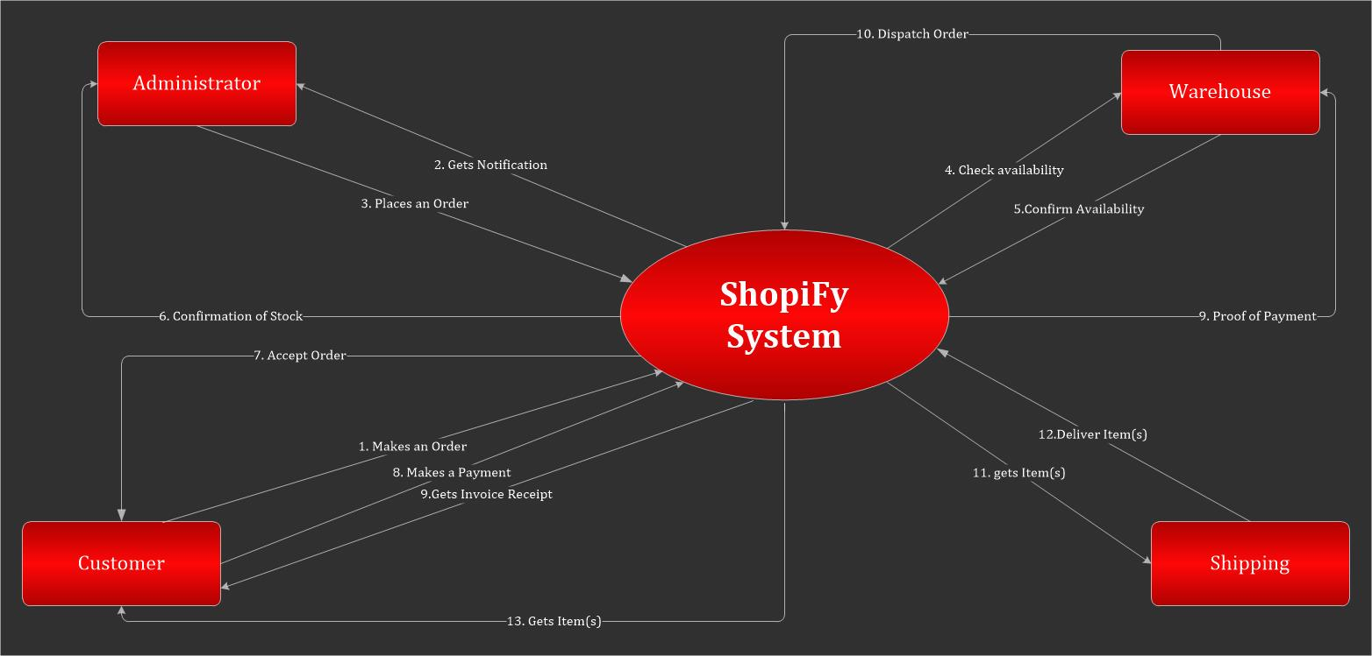

Figure 1- Context Diagram

# **User Interfaces**

**Screen shots and menu designs**

Below are the screen shots and menu designs of the application:

* **Home Page**

On the home page you will find the overview of the application.

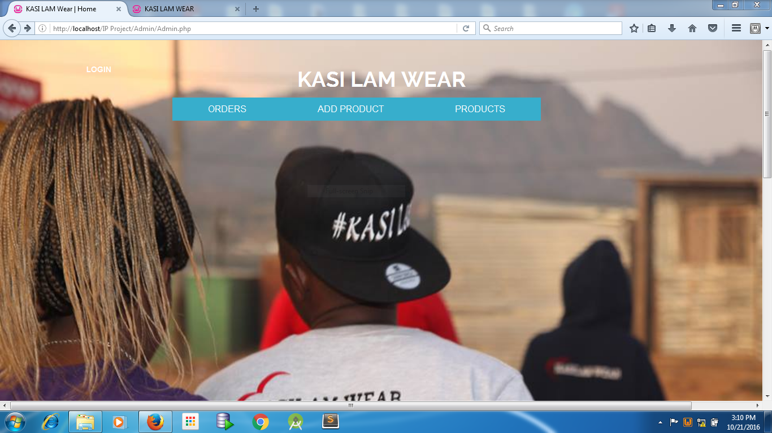

* **About Us Page**

The about page will give a brief information about the cart or the business, when was the business started, the vision and the mission of the business.

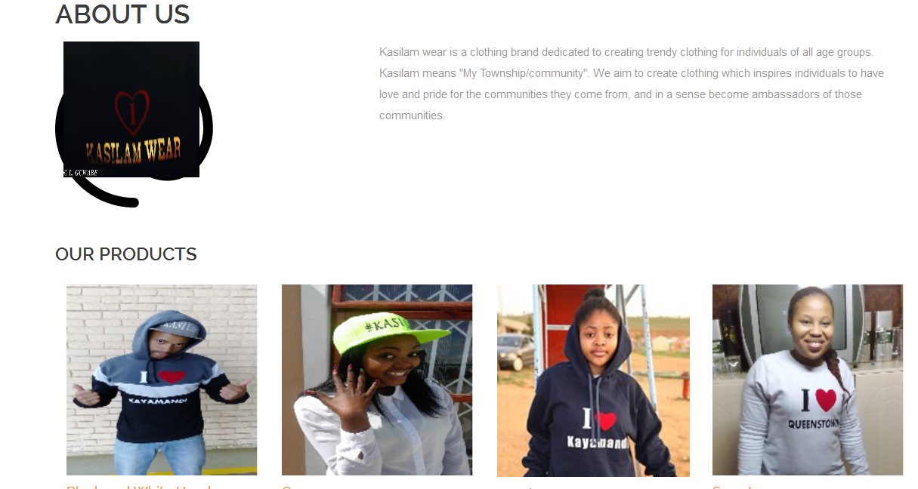

* **Contact Us Page**

The page will contain the business contact details including the map for the location of the warehouse. The will also a form that will be available on the contact us page that can be used as a shortcut to contact the business.

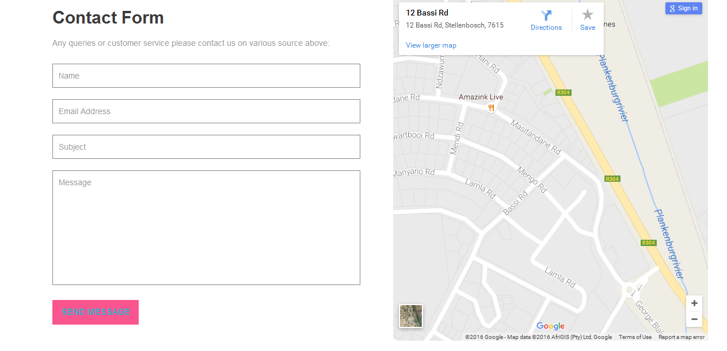



* **Login page**

The customer will have to login to the system in order to make an order otherwise they can only navigate the system. If the customer is not registered then the customer will have to register first.

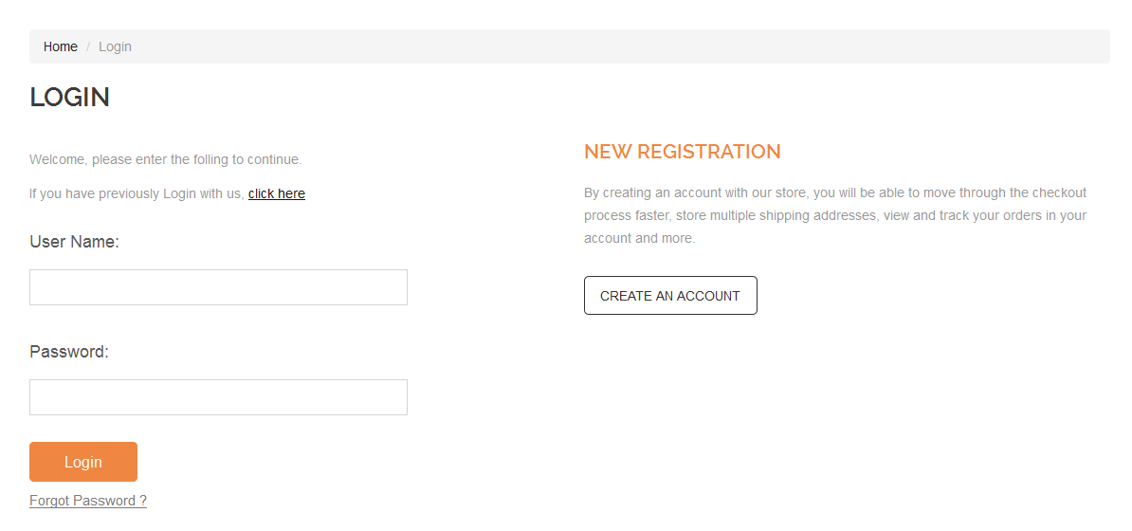

* **Registration Page**

A new customer must register by filling the registration form.

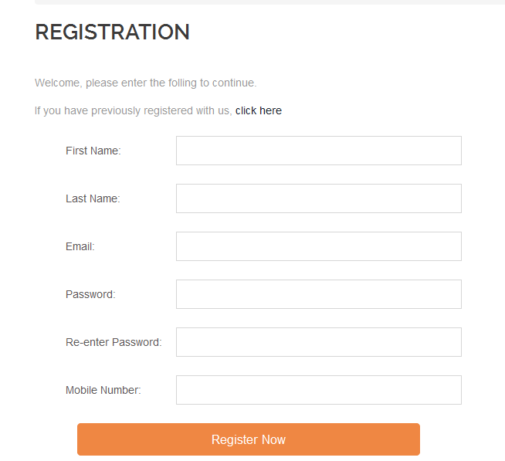

* **Shopping Cart**

The customer will navigate and select the categorized items on the shopping cart.



* **Adding to Basket**

Given that the customer has logged in then the customer can continue and add items on the basket, checkout and make payment.

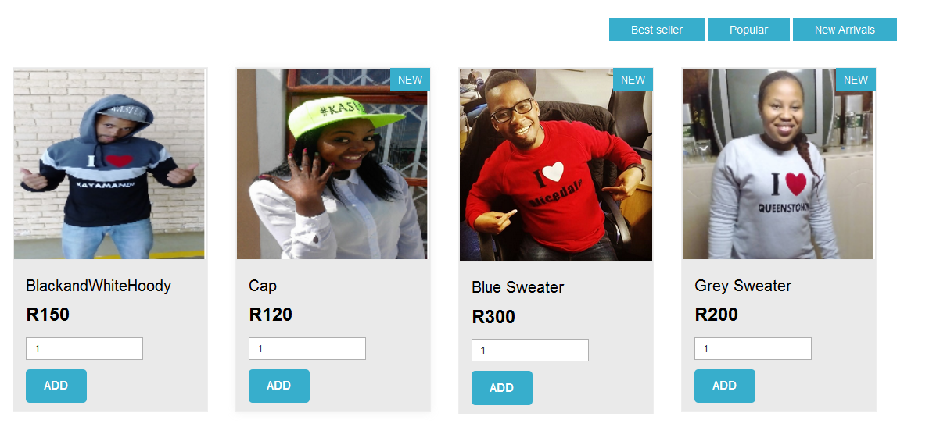

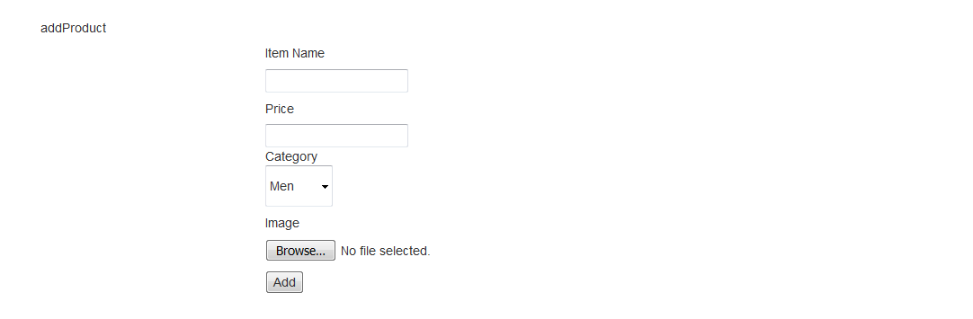

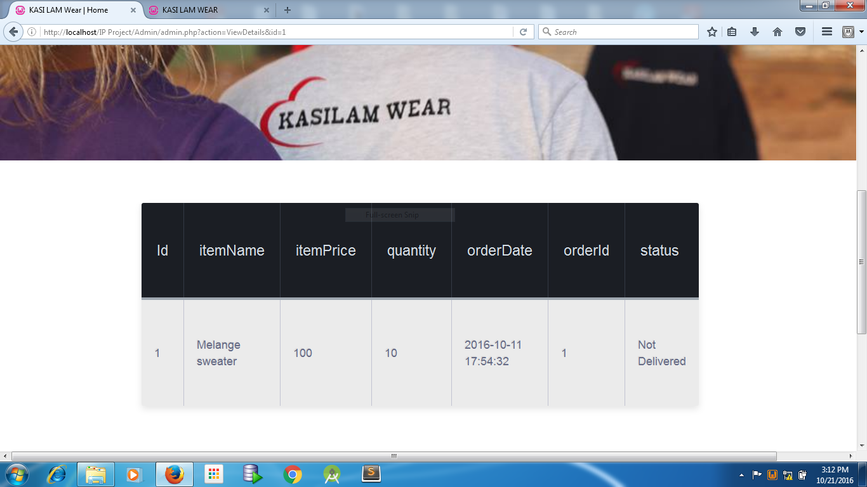

# **Business Rules**

There are few rules that our company will mainly focus on, namely:

* **Order Entry**

Orders will only be placed if there is stock available. Should the stock be unavailable the customer can wait and will be notified when the item is on stock.

* **Order Changes**

Customer can change the order up to 48 prior the proposed delivery date. After that the customer can return the item if not wanted anymore.

* Exchange and Refund
* Items order can be returned for refund within 14 days after shipment.
* Items returned after 14 days, customer will have to pay extra 10% of the original price of the Item.
* Returned goods must be still in good condition, must still have a price tag.
* Refund will only be paid if the item is still as it was.
* No exchanges or refunds for sale items.
* Refund will be paid directly to the card that was used to make payment for the purchase.
* **Shipment**

Delivery will take up to 14 working days, depending on the province the customer resides.

* **Terms of Payment**

Customer can use credit card to pay for the order. An option of cash on delivery will also be available for those customers who don’t have credit cards.